

Software Requirement Specification
For EMP

MODULE INTERVIEW MANAGER

Version: 01f

Revision History
Date | Version | Description | Author
02/08/2011 | 01a | Create New | ITeal
30/08/2011 | 01b | Updated:  - Notification  - Versioning  - Multi-language  - Search  Add new:  - Interview Manager | ITeal
30/08/2011 | 01c | Remove "Import / Export / Copy"  Modify:  - User & Right Management  - Interview Manager | ITeal
08/09/2011 | 01d | Response : CIRC's feedback | ITeal
14/09/2011 | 01e | Update SRS based on the Skype conference on 13/09 | ITeal
23/09/2011 | 01f | Update follow the remark on 01e | ITeal

Table of Contents
1.1 INTRODUCTION 4
1.2 Import Setting 5
1.2.1 IMapp is installed with MSApp at IARC 5
1.2.2 IMapp is installed in decentralized mode 5
1.3 Upload Interview 5
1.4 Folder Management 7
1.5 Import Interviews 8
1.5.1 Import 1 Interview File 8
1.5.2 Batch Import of Interviews 9
1.5.3 Management for Archive Files 9
1.6 NOTES Processing 10
1.6.1 General 10
1.6.2 NOTES Concept 10
1.6.2.1 Notes attached to an Item 10
1.6.2.2 Note Status 12
1.6.3 Notes Selection 12
1.6.4 Display the Notes List 12
1.6.5 Update Notes 13
1.7 Filter & Export Inverviews 13
1.7.1 Filter the interviews 13
1.7.2 Display the Interview List - Export 14
1.7.3 Interview Purge 14
1.8 Subject management 14
1.9 Multi-Language 15
1.10 Installation of Interview Manager in decentralized Mode 15
1.11 Added IARC Remarks 16
1.12 Still to be discussed: 16
2. ANNEX 1 : Subject management 19

Interview Manager
  - INTRODUCTION
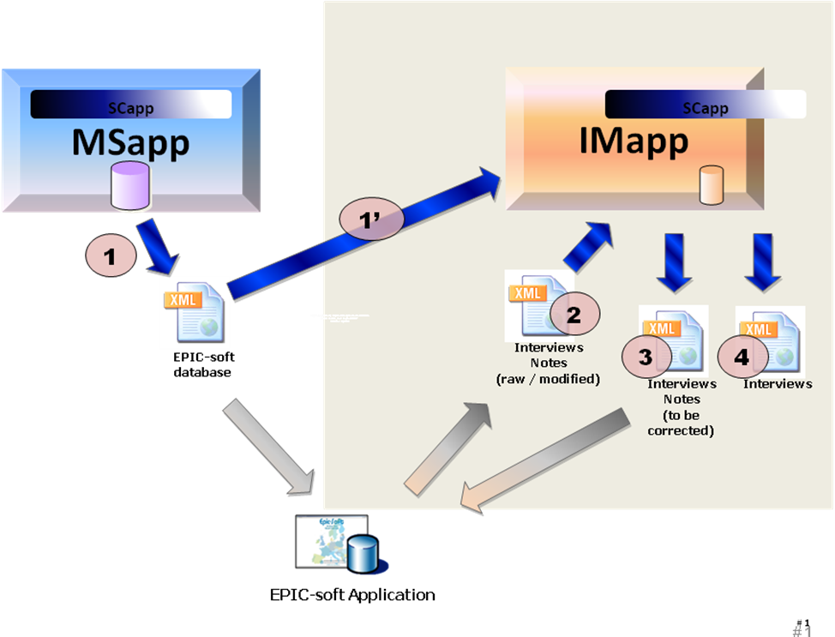
- Interview Manager
The objective of this module is to gather the interviews from Epicsoft Application, to process the notes and status attached to these interviews and to send the interviews to EPIC-Soft application for update. It contains the following business:
- Import the EPIC-soft database (xml) file (generated by MSApp) (1')
- Upload interviews on the platform (end-user task)
- Import the Interviews (xml) and notes from Epicsoft Application: (2)
- Original Interviews and Notes OR
- Modified Interviews and Notes: Epicsoft Application received interviews and notes from IMApp for correction and then, the updated interviews are sent again to IMApp.
- Manage the subject information (ex: problem of subject code, birth date and sex, predefined list of subject to be interviewed)
- Manage the Notes attached to the interviews
- Re-compute the interviews (Not include in this scope)
- Export Interviews (xml) that need correction from Epicsoft Application (3).
- Export Interview: used for external purposes such as statistic…

Note:
- Several iterations of flow 2 & 3 are possible; this will be finished until no more correction is needed for interviews and notes. For each new iteration, IMApp stores a new occurrence of Interview (new version) in the database.

In addition, the Interview Manager will include the following services:
- Manage versions of Interviews (in iterations)
- Handle error during import; correct the errors on Subject information (Code, sex, birth date…).
- Manage the Subject Code to be interviewed.
  - Import Setting
    - IMapp is installed with MSApp at IARC
IMApp can use the data from MSApp directly, no need to import anything.
    - IMapp is installed in decentralized mode
- Used for Upload, Import Interview:
- Identification of setting: Project – Version – Country – Used Language and an Identification of the interview version.
- Use for Recompute: TBD

The imported setting will replace the existing setting in IMApp. The imported setting is an upgraded version.
Note: We can import data of one project/sub-project/country with 2-3 different languages (ex: Belgium).
  - Upload Interview
This part will describe the flow that the end-user uploads his interviews into EMP systems and how the uploaded files are stored in EMP.
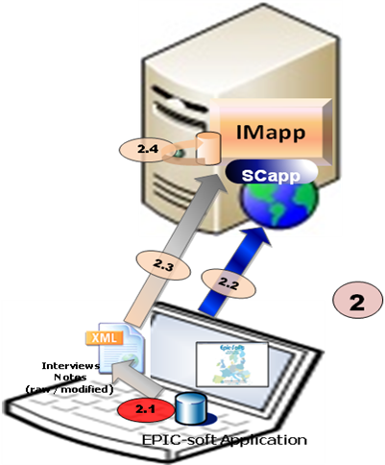
- Import Interviews from Epicsoft Application
- (2.1): The end user exports interviews with attached notes from Epicsoft Application (files are in a certain directory of his PC), the exported interviews files will be grouped in an xml file (provide a file name containing the date, time and version)
- (2.2): The end user connects to EMP, the module SCApp authenticates him and assign the access rights to selected project / sub-project (*) / country / data language.
CC: we decide to call it sub-project instead of version.
- (2.3): The end user uploads the archive to the server:
- IMApp display a file selection that asks the user to select the files he wants to upload (the supported file will be *.xml, *.rar, *.zip or all three types). The user can select 1 or multiple files at once.
- IMapp checks if the data are consistent with the rights of the end user (user must have rights on the projects / sub-project / countries the data belongs to).
- IMapp inform the Coordinator by the communication means of SCApp (TBD) to alert that interviews have been uploaded.
- IMapp display a message that let the end user confirm the upload of the file, this message should also inform the end user that this loaded interview dataset has also to be saved in a dedicated folder on her/his PC + on other support (backup). Such as (this message is defined in database, we can change this later if needed, it's multi-languages also):
- 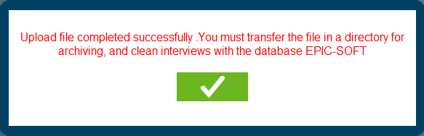
- Note:
- IMApp will implement an interface to manages the uploaded files with status and logs (xml only, for zip, rar files → we'll get all xml from the zip, rar to manage).
- Xml-file name: to the name given by the end-user, the date and hour of the upload have to be added or this information kept by another mean
- Check the consistency of the xml file:
1. Check File format (xml)
- In the File selection Dialog: User can select xml, zip, rar only
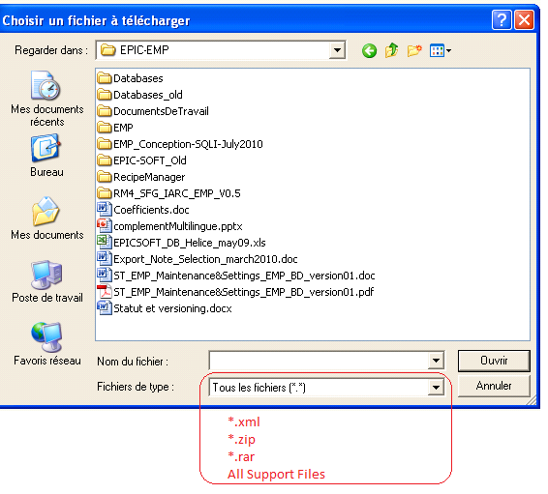
- In the case of zip or rar file: Check the contents
→ If all is xml file → OK
→ If there's other file (not xml) → this file is uploaded, the non-xml files are ignored and a warning like this is displayed "The zip (rar) contains files that isn't in xml format, these files will be ignored".

2. Check xml file
- Check that xml file is in correct format (xsd schema)
- Decode xml file & Check the corresponding of project-sub-project-country-language in xml file with the project-sub-project-country-language as selection of user.
→ If the check failed → Display error message and the file can not be imported.
3. User can delete uploaded file (successfully uploaded): Maybe he (she) want to replace it by a newer file.
  - Folder Management
IMApp will use folders to classify the interview. The folders will be managed as following:
- The user will be able to create folders (1 level directory only),
- A folder is attached to 1 Project–Version–Country and be managed virtually in database (not in hard-disk).
- It's not possible to have 2 folders with the same name inside 1 Project–sub-Project–Country.
- 1 Interview can be stored in 1 folder only.
- It's possible to rename the folder, remove empty folder or move interview(s) from 1 folder to another.
- IMApp will have a simple interface to see the folder list where the user can select a folder to display all its interviews.
- CC: In this screen, we will need a search facility and a function to select several interviews in order to move them in another folder.
  - Import Interviews
After uploading into IMApp by end-users, the interviews have to be stored in the database of IMApp. The Coordinator will have to:
- Select a Project-sub-project / country / language when he/she logs in,
- Select one or several uploaded files,
- Import them into the database of IMApp.
In the IMApp, only interviews files from 1 project-version-country-language can be imported at once. The coordinator can select one or several files to consolidate at the same time.

IMApp must provide a simple interface allowing the user to select interviews files to import. Before that, the user must specify the project- sub-project-country-language, he's working in.

Controls:
Checks on interviews specificities
Checks on subject information
    - Import 1 Interview File
When importing 1 xml file, the IMApp will decode the xml file and process the import interview by interview:
- (1): Check the Identification of the Interview by: Project + Sub-project + Country + data Language + Center + Subject + Recalled Date.
- (2): Check existence of Interview in database:
- If the Interview is available in database (same values for all these fields):
→If Flag of Interview = "Not Exported" → System will generate 1 error message to inform the user that the interview already exist in IMApp without having been exported first and abort the importation.
→If Flag of Interview = "Exported": System will increase the version number of the interview being imported by 1, store the interview with this new version number and update the Flag of this interview to "Not Exported" to enable the use of this interview (export, edition).
- If the Interview isn't present in database: Store the interview with the initial version number (V0) and set flag to "Not exported".
- (3): Control the Subject: Check if the imported subject code exists:
- IF YES (Subject code exists)
→ IF information on sex & birth date is identical THEN link the interview to this subject
→ IF information on sex & birth date is different THEN display a warning (*) and create a new subject with a temporary subject code
(*) If Warning: the problems are written in a log file, and the process continues with the Subject creation indicating ‘temporary subject code’. The coordinator should change it later with the appropriate subject function.
- IF NO (subject code does not exists) → OK : creation of the subject

Notes: To manage the subject list, 3 solutions are possible for the coordinator:
- A predefined list with all subject information can be entered in IMapp so the controls on code+sex+birth date can be done efficiently
- The subject list is not pre-entered, so the list is generated automatically during the recall import (flagged as new subject). Remark: the controls on code+sex+birth date will be performed only in case of import of several recalls for the same subject.
- A predefined list of incomplete subject information (e.g. code only; or code + sex) can be entered in IMapp so only the control on the available information can be done. Then the missing information (sex and/or birth date) are imported.
- (4) Interview data import
- At the end of the interview loading, a last check is performed on the level of the interview data coherence with the imported parameters (e.g. whether the food consumption occasion (FCO) code exists in the list of imported parameters)
- In case of data incoherence, an error message like ‘parameters incoherence’ will appear (including the details about the incoherence problem)? The incoherent parameter (e.g. FCO) will be flagged.

NOTE: If an error occurred during the import of a set of interviews (xml-file), the problem is noticed in a log-file and all the interviews of this set are not imported.
    - Batch Import of Interviews
In the Import screen, the coordinator can select one or multiple files to be imported. In the case of multiple files, the IMApp will do as the following:
- Do the importation file by file as in 1.5.1
- If error occurs on 1 xml file, this file will be ignored (save log) and the IMApp will go to next file.
- After importation of all archives, IMApp will display the summary that contains the log for all importations: success or error, cause of error…
    - Management for Archive Files
IMApp must implement a mechanism for managing the xml files (xml) on the server. Xml files can have the states as following:
- "Uploaded": Indicate that the xml has been uploaded by an end-user → the coordinator can import archive in this state.
- "Imported": Indicates that the file has been imported successfully by the coordinator. Imported files will be removed automatically after the import has been done without problem.
- "Error": Indicate that there were errors during the import of this file. In this case a function has to be implemented to allow the coordinator to see a log of the import attached to this “error file”.
- End user can do the following actions on archive file:
- Delete his "Uploaded file"
- The coordinator can do the action like end-user and:
- Delete the imported file.
- Delete the Error file (The import is not possible even if the setting is up to date.)
- Delete the "Uploaded" File
- Note:
- For the "Uploaded File": User can upload another file with the same name, in this case the system will ask the user to confirm to overwrite of the existing file.
- For the "Error file": User can not delete or replace this file, if the user upload another xml file with the same name → IMApp will add a number to the file name and inform user about it by a message.
- Coordinator can see the log of import of "error file"; he (she) can remove it and require the end-user to re-upload a new file.
  - NOTES Processing
    - General
NOTES processing will implement the following functions:
- View & Filter Notes
- Update notes’ status & comment manually
- Function for Recompute Module (TBD)
    - NOTES Concept
      - Notes attached to an Item
Notes are data available in interviews database. A note is always attached to an item that involves:
- General Notes attached directly to a Subject
- Specific Notes attached to a:
- FCO (Meal)
- Quick list item (QLI)
- Food/fat
- Recipe
- Ingredient
- Supplement
"Note Type" indicates which item the note is attached to and the reason the note was created. This field is stored in the database but can not be used to filter & view the notes.

The following tables will show the possible notes in IMApp:
ITEM | NOTE TYPE | TYPE  CODE | Comments | Manual vs Auto
Subject | General | G |  | Manual
Subject | Special diet | G_DT | Note for “Other” field for special diet | Automatic
Subject | Special day | G_DY | Note for “Other” field for special day | Automatic
FCO | Specific | SPE |  | Manual
QLI | Specific | SPE |  | Manual
QLI | Empty | EMP | If a Note already exists, the type code is not changed. | Automatic
FOOD | New food | NEW_F | Message “New food” writes | Automatic
FOOD | Specific | SPE | If a Note already exists, the type code is not changed. | Manual
FOOD | Unknown quantity | UNK | Message “Unknown quantity” writes.  If a Note already exists, the type code is not changed. | Automatic
FOOD | Null quantity | NULL | Message “Null quantity” writes.  If a Note already exists, the type code is not changed. | Automatic
FOOD | Overflow quantity | OVER | Message “Overflow quantity” writes.  If a Note already exists, the type code is not changed. | Automatic
RECIPE | New recipe | NEW_R | Message “New recipe” writes | Automatic
RECIPE | Commercial recipe | COM | Message “Commercial recipe” writes | Automatic
RECIPE | Open unknown recipe | I_ADD | Message “Open recipe: added ingredient” | Automatic
RECIPE | Open unknown recipe | I_DEL | Message “Open recipe: deleted ingredient”
RECIPE | Specific | SPE | If a Note already exists, the type code is not changed. | Manual
RECIPE | Unknown quantity | UNK | Message “Unknown quantity” writes.  If a Note already exists, the type code is not changed. | Automatic
RECIPE | Null quantity | NULL | Message “Null quantity” writes.  If a Note already exists, the type code is not changed. | Automatic
RECIPE | Overflow quantity | OVER | Message “Overflow quantity” writes.  If a Note already exists, the type code is not changed. | Automatic
INGREDIENT | New food | NEW_F | Message “New food” writes | Automatic
INGREDIENT | Specific | SPE | If a Note already exists the type code is not changed. | Manual
INGREDIENT | Unknown quantity | UNK | Message “Unknown quantity” writes.  If a Note already exists, the type code is not changed. | Automatic
INGREDIENT | Null quantity | NULL | Message “Null quantity” writes.  If a Note already exists, the type code is not changed. | Automatic
SUPPLEMENT | Specific | SPE |  | Manual
SUPPLEMENT | Null quantity | NULL | Message “Null quantity” writes.  If a Note already exists, the type code is not changed. | Automatic
 | Specific | F_xx | XX for the supplement facet number. See Table DS_Facet.  Examples :  F_01= other source, F_03= other place, F04=other packing | Automatic
- Possible Note types in IMApp
      - Note Status
A Status is attached to each note. It will be used to indicate the current state of the note and the actions to do on the item. Each status will have an attribute attached called S_Hide indicating if the note in this status must or mustn't be displayed.
The note’s status is project dependant except for the modality “New” (coded 00) that is automatically attributed at the note creation by ESapp.
Example of note status list:
Value | Description | S_Hide
00 | New (mandatory) | No hide
01 | Ongoing | No hide
02 | No action needed/Ignore | Hide
03 | Action approved by coordinator | No hide
99 | Action done | Hide
- Note Status
By default IMApp will not display Notes with status "Hide".
The Note’s status value will be specific for each project and has to be imported from MSApp.
    - Notes Selection
IMApp will display all notes of Project – Sub-project – Country – Language (selected by user) in a grid. User can do the filter by clicking on the header of each column (like excel 2007 and later).
The following data of interview will be displayed in the grid and can be filtered by:
- Folder
- Note Status
- Note Type
- Region
- Subject Code (or subject code can merge country+region+subject code)
- Subject Sex
- Birth year
- Recall Date
- Sp. day
- Sp. diet
- Interviewer Code
- Type of record (e.g. food, recipe, fat…)
- FCO (why ?)
- Classification (Group/Sub Group/Sub-sub Group)
- Food / Recipe name or FCO name (that means value of “Name” column but when this column is empty then value of “Text” column)
- Consumed quantity

[dtta]: We updated this part with latest version (spec) of SQLI, I don't know if it has been change, so shall we remove the FCO?
    - Display the Notes List
The Filter will be done with the latest versions of interviews. The filter result will be display in 1 note list (mode List). The information in the list must be enough to identify one note.
User can double click on each row to open 1 interface that contain all information of the note (read-only), user can also modify some information on it (note status and comment).

It's possible to open the interface to the interviews associated with 1 note.
In this screen we can see the items with attached notes. For the user, it can be interesting to have a function that allows seeing all the interview records attached to this note.
    - Update Notes
Only Notes attached to the latest version of an interview can be modified.
In IMApp, the following information can be modified:
- Comment: free text
- Status: The status of note can only be updated by user manually (no automatic update by IMApp)
These informations can be modified in the following ways:
- In the Note List: User can select one or several notes to be updated, then input status and comment (once for all selected items) and click on a button to update for all. The comment of all the selected notes will be replaced by this new one.
- In the "Note details" interface: user can update the comment and status of one selected note.
  - Filter & Export Inverviews
    - Filter the interviews
IMApp will display all interviews of Project – Sub-project – Country – Language (selected by user) in a grid. User can do the filter by clicking on the header of each column (like excel 2007 and later).
The following data of interview will be displayed in the grid and can be filtered:
- Folder
- Exported. → to be confirmed
CC: In fact by default only the non-exported intervews will be displayed. We can image a button to change this option and to display only exported interviews (or both??). We can also just propose a button to export the list of “exported interviews”, list of subject code + recall data + general information). I am not sure that this column is necessary. To be discussed
- Region
- Subject Code
- Subject Sex
- Birth year
- Recall Date
- Sp. day
- Sp. diet
- Interviewer Code
- Type of record (e.g. food, recipe, ingredient…)
- FCO (why?)
- POC (no)
- Classification (Group/Sub Group/Sub-sub Group)
- Food / Recipe name or FCO name (that means value of “Name” colomn but when this column is empty then value of “Text” column)
- Consumed quantity
- Note Status
- Note Type

Note:
- The Filter will be done with the latest versions of interviews.
- IM can display "Exported" and "Not Exported" interview separated by background color of grid.
- User can see the Information of "Exported" Interview but can not make any modification
CC: In fact by default only the non-exported intervews will be displayed. We can image a button to change this option and to display only exported interviews (or both??). We can also just propose a button to export the list of “exported interviews”, list of subject code + recall data + general information). I am not sure that this column is necessary. To be discussed

[dtta]: I think, we should have a check button like "Display Exported Interview", user can click on this to display the exported interview or not, what do you think?
FCO: same with the part Note selection

Gwh: yes.
    - Display the Interview List - Export
The filter result will be display in 1 Interview list (List mode). The information in the list must be enough to identify one interview.
User can select one or multiple interviews and do the following actions:
- Export to Epicsoft Application: in xml format
- In this case, the selected interviews are exported in xml-file and flagged as “exported”. The user cannot update or re-export these interviews. System will notify (by the communication means of SCApp) the selected end-user about this exportation (specified by the coordinator). The generated xml-file has to be stored on a dedicated folder.
- After having received the notification, the end-user has to connect to the platform and regarding their user rights can select the xml-file and download it to her/his PC.
- For each export, a report is generated containing the list of exported interviews.
- Export to External File (CSV, xml): User can choose between the 2 export types:
- Complete: all information of selected interviews will be exported.
- Simplify: Certain data will be exported (TBC in SDD)
- In this case, the flag/indicator for export is not activated / modified.
    - Interview Purge
IMApp will implement a function that allows the user the purge versions of interviews. The first (raw) and the last interview version cannot be purged.
CC: do we have to allow the users to select the interviews to be purged or all of them will be automatically purge?
[dtta]: In my opinion, we should implement a screen that allow user select the "Intermediate version" of interviews with some filters, in this screen he (she) can select the interviews to purge or choose to purge all. What do you think?

Gwh: yes.
  - Subject management
This function includes:
- Filter the Subject by:
- Code (region – ID code)
- Temporary
- Sex
- Birth Date (TBD)
- Name (optional)
- Surname (optional)
- Recall date
- Display the subject found by filter in a grid with:
- Code (region – ID code)
- Temporary
- Sex
- Birth Date
- Height
- Name (optional)
- Surname (optional)
- Recall date (we can have several recall date per subjects)
- Interviewer code
- Interview number
- Modify the Subject's information: Code, Temporary, Name, Surname, Sex, and Birth Date, and Height.
- In case of update of a subject code:
- Check that the new code is not already affected
→ If not then the update is done on all the interviews attached to this subject (also all the interviews’ versions)
→ If yes then
+ If the recall date doesn’t already exist for this new subject code then change the subject code
+ If the recall date already exist for this new subject code then the change is not possible.
- In case of update of a subject recall date:
- Check that the new recall date doesn’t already exist for this subject
→If not then the update is done on all the interviews attached to this subject (also all the interviews’ versions)
→If yes then the change is not possible.
- In case of update of a subject sex, birth date, name, family name… the update is done with control.

See the ANNEX 1 : Subject management for the Control of Subject's information.
  - Multi-Language
In EMP, 1 country can have more than 1 language such as Belgium (French, German…), the end-user can select different language to download the Epicsoft Database and the interviews made by them will be in the language that they selected to download. So in this case the interviews in 1 country can be in different languages.
CC: in fact, ESapp is running with an Epicsoft database defined for 1 project, 1 country and 1 language. So in case several languages are available for 1 country, the coordinator will have to export several Epicsoft databases for the same country; 1 per language.
When an user connects to the EMP, they select Project – sub-project – Country – Language and then filter the interviews / notes, the interviews / notes will be displayed to him (her) in the same language as when they were made (no translation even if they're in different languages).

Note:
MSApp Database contains the translation for all data of Epicsoft Database; we can translate the data in different languages by using the code (Food, Recipe, supplement…) except for the Note comments that cannot be translated because it is open text.
  - Installation of Interview Manager in decentralized Mode
EMP will implement the 3 modules: SCApp, MSapp and IMapp independently. [Gwh: MSApp and IMApp are independent regarding each other but they both depend on SCApp] In decentralized mode we need to have 2 modules, SCApp and Imapp, deployed on a local server. There is no synchronization directly between CIRC's server and any local server. To operate in decentralized mode, the SCApp and IMApp will need some data:
- Identification of Project, Country, User data (information + roles): can be imported from xml file and screens need to be developed to enter these informations (administration SCapp)
- Data used for Recompute (TBD – may be all MSApp database)
We can export this information from CIRC’s servers and import it to the local server.
See point 7.9 of SFG that gives more details on this part.

[dtta] → The following parts will be removed later, We keep it for trace purpose
  - Added IARC Remarks

- SEARCH and HMI: From the existing IMapp, in the SEARCH part of the screen, we can see within the field what has to be enter (e.g. « Language name », « Language code ») but once we have entered a value, it is no more possible to see the field name so to known what has to be entered. It is necessary to improve it, for exemple, by moving the mouse on the field and we can have a balloon with the field name.
→ we keep this as note when design the interface

- Management of the Interview number: The interview number is given by the interviewer with ESapp so mistake can be entered in this field. In order to correct these wrong values, a compute can be implemented to re-attribute automatically the interview number according to the recall date during the import OR in the Subject management screen, a function can be added to allow the user to correct them.
→ (3) in 1.5.1
CC: Do you mean, that this field will be updated during the Import? It can also be updated manually in the subject management screen
[dtta]: yes, it's also applied in Subject management.

- View Interview: It is not possible to see the content of an exported interview neither to have the list of exported interviews (flagged as exported). It is necessary to add a new screen or to improve the Edition screen.
→ updated in 1.7.1
- Interview Purge: A function need to be implemented to allow the user the purge the version of the interviews. The first (raw) and the last interview versions have to be kept.
→ updated in 1.7.3
  - Still to be discussed:

Using IMapp, we can have update in:
- the note screen (statuts & comments)
- the subject screen (general information on subject)
- the folder screen (create, delete, update the label)

And we have differents Actions:
- folder management (e.g. move interviews from one to another)
- upload
- import
- export

- Do we need to keep the notion of « Who » & « When », the action, update has been done ?
- Do we need a notion of validation, if several users can update the data?

- ANNEX 1 : Subject management

- Display the subject information with:
- Code (region – ID code)
- Sex
- Birth Date
- Name (optional)
- Surname (optional)
We can have several recalls per subject with these specific informations:
- Recall date ()
- Interview number (1 per interview)
- Height
- Weight
- Interviewer code (1 per interview)
- Temporary flag. This flag means “records to be updated” and is set to yes when a problem of incoherence occurred during the import.

Update with flag “temporary” = 0 (no):

- If update on fields 6, 7, 8, 9, 10 – update on 1 interview -
- The update is applied to all the versions of this updated attached interview.
Special case:
- update on Recall date:
  - If the recall date already exists for this subject Then error message
  - Else update done on all attached interview versions.
- update of Interview number / height / weight / interviewer code
  - Update done on all attached interview versions.

Gwh: there’s an interrogation about updating the version 0 (first imported and considered as “original”). Can it be kept as is and never modified while still keeping the filiation link with newer versions ?

- If update on fields 1, 2, 3, 4, 5 – update on 1 subject -
- The update is applied to all the interviews attached to this subject and also to all the attached interview versions.

Special cases:
- update on code (region – ID)
  - If the Region+ID already exits in the interview data Then
    - Display a summary pop-up with the informations of the existing subject along with all the interviews attached to this subject and a way to compare this with the informations and interviews of the subject being modified.
    - If no interviews have the same recall date for this subject then the update is possible. (Which values for the fields sex & birth date if not the same?)
    - Ask for confirmation
    - If interviews with same recall date for this subject then the update is not possible → error message
Example:
Summary screen:
Region – ID – recall date
001 – 0125B – 11/02/2011
001 – 0125B – 08/03/2011
001 – 0125B – 12/05/2011

001 – 0125C – 08/03/2011
001 – 0125C – 10/04/2011

Asked change: code 001-0125C changed by 001-0125B
Before After
001 – 0125B – 11/02/2011 001 – 0125B – 11/02/2011
001 – 0125B – 08/03/2011 001 – 0125B – 08/03/2011
001 – 0125B – 12/05/2011 001 – 0125B – 12/05/2011
001 – 0125C – 08/03/2011 001 – 0125C – 08/03/2011 → problem interview already exists
001 – 0125C – 10/04/2011 001 – 0125C – 10/04/2011 → OK
➔ In this case the update is not possible so error message. The user will have to change first the recall date 08/03/2011 of the subject 001 - 0125C.

- update on sex Birth Date, Name, Surname :
  - The update is applied to all the interviews attached to this subject and also to all the attached interviews’ versions.

Update with flag “temporary” = 1 (Yes -> loaded with problem):

This case occurs only when the subject code already exists and when the sex/and birth date of the subject is not the same as the already entered one.

In this case we have 2 possibilities:

- attach the record “temporary” to an already existed one

  - If same Id code but different birth date and/or sex:
Control on the recall date:
If date already exists for the attached subject then error message
Else
Ask to the subject the correct sex and birth date proposing between the 2 possible values (per fields) & change the flag “temporary=yes” by “no”.

  - If same id code, same birth date, same sex and same recall date
The user can change the recall date and/or the subject ID and link this record to another one.
If not the same sex and/or birth date then ask to the subject the correct sex and birth date proposing between the 2 possible values (per fields) & change the flag “temporary=yes” by “no”.

- change the subject ID by a new one (not already existing)
  - The flag “temporary=yes” is changed by “no”

